Nikit Gokhe

Class – Comp D1

Roll No. 224021

GR No. 21810522

**ASSIGNMENT NO.03**

**AIM:**

To​ design and develop SQL DML statements which demonstrate the use of SQL statements such as join, queries and view.

**OBJECTIVE:** To learn SQL objects such as join, view. ​

**THEORY:**

SQL: It​ is a standard Database language which is used to create, maintain and retrieve the data from relational databases like MySQL, Oracle, SQL Server, etc. As the name suggests, it is used when we have structured data (in the form of tables).

DML: Data Manipulation Language (DML) deals with the manipulation of data​ present in the database belong to DML or Data Manipulation Language and this includes most of the SQL statements.

VIEW: I​​n SQL, a view is a virtual table based on the result-set of an SQL statement.A view contains rows and columns, just like a real table. The fields in a view are fields from one or more real tables in the database.You can add SQL functions, WHERE, and JOIN statements to a view and present the data as if the data were coming from one single table.

**INPUT:**

CREATE VIEW Syntax

CREATE VIEW view_name​ ​AS

SELECT column1​ ​, column2​ ​, ...

FROM table_name​

WHERE condition​ ​;

UPDATING A VIEW:

A view can be updated with the CREATE OR REPLACE VIEW command.

SQL CREATE OR REPLACE VIEW Syntax

CREATE OR REPLACE VIEW view_name AS SELECT column1, column2, ...

FROM table_name

WHERE condition;

DROPPING A VIEW:

A view is deleted with the DROP VIEW command.

SQL DROP VIEW Syntax

DROP VIEW view_name​ ​;

JOIN: ​ A SQL Join statement is used to combine data or rows from two or more tables based on a common field between them.

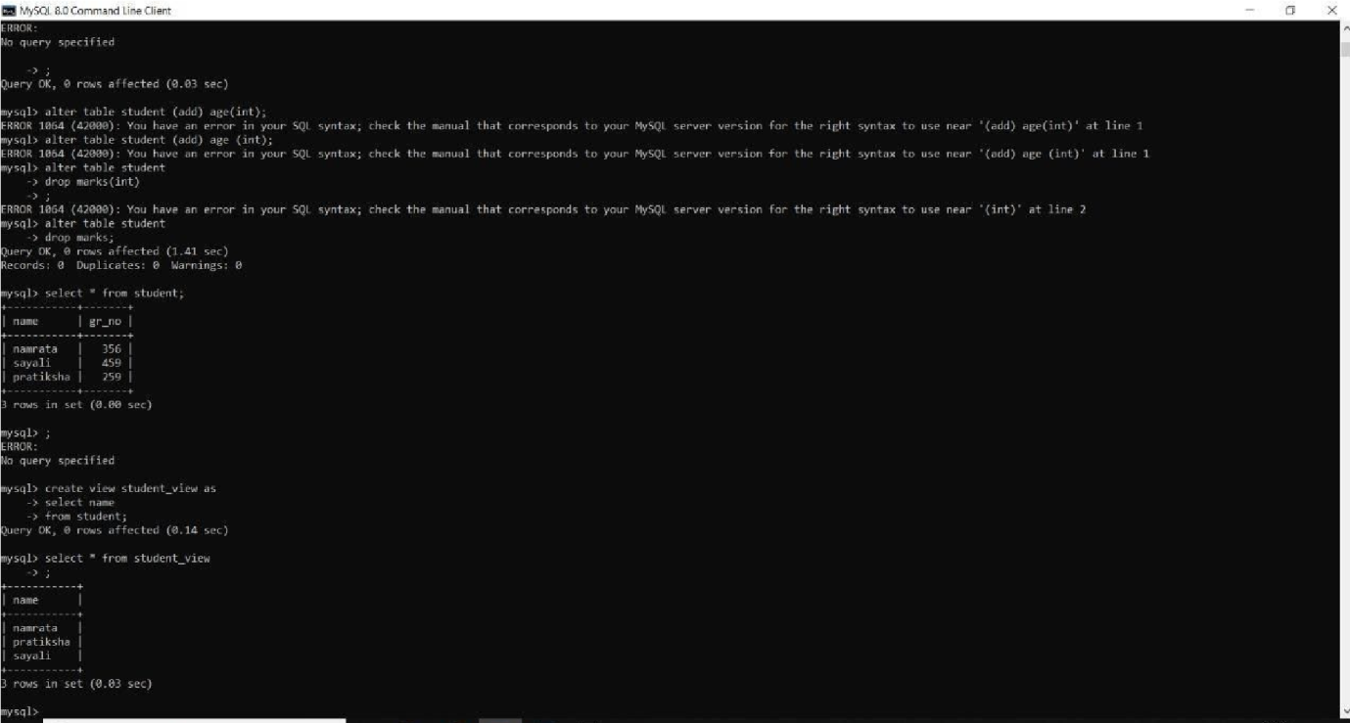

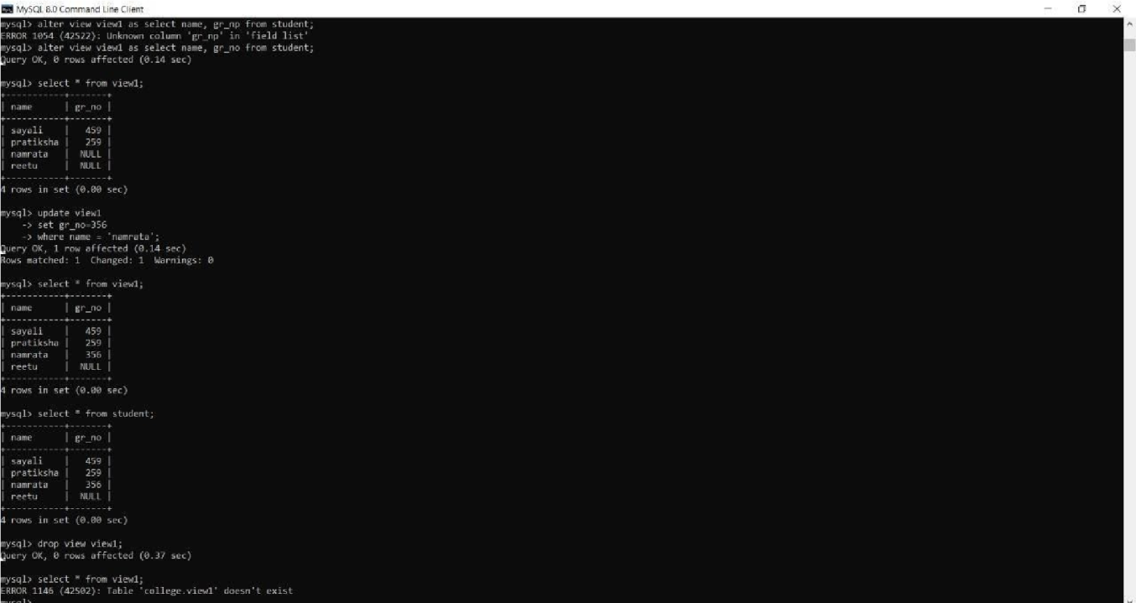

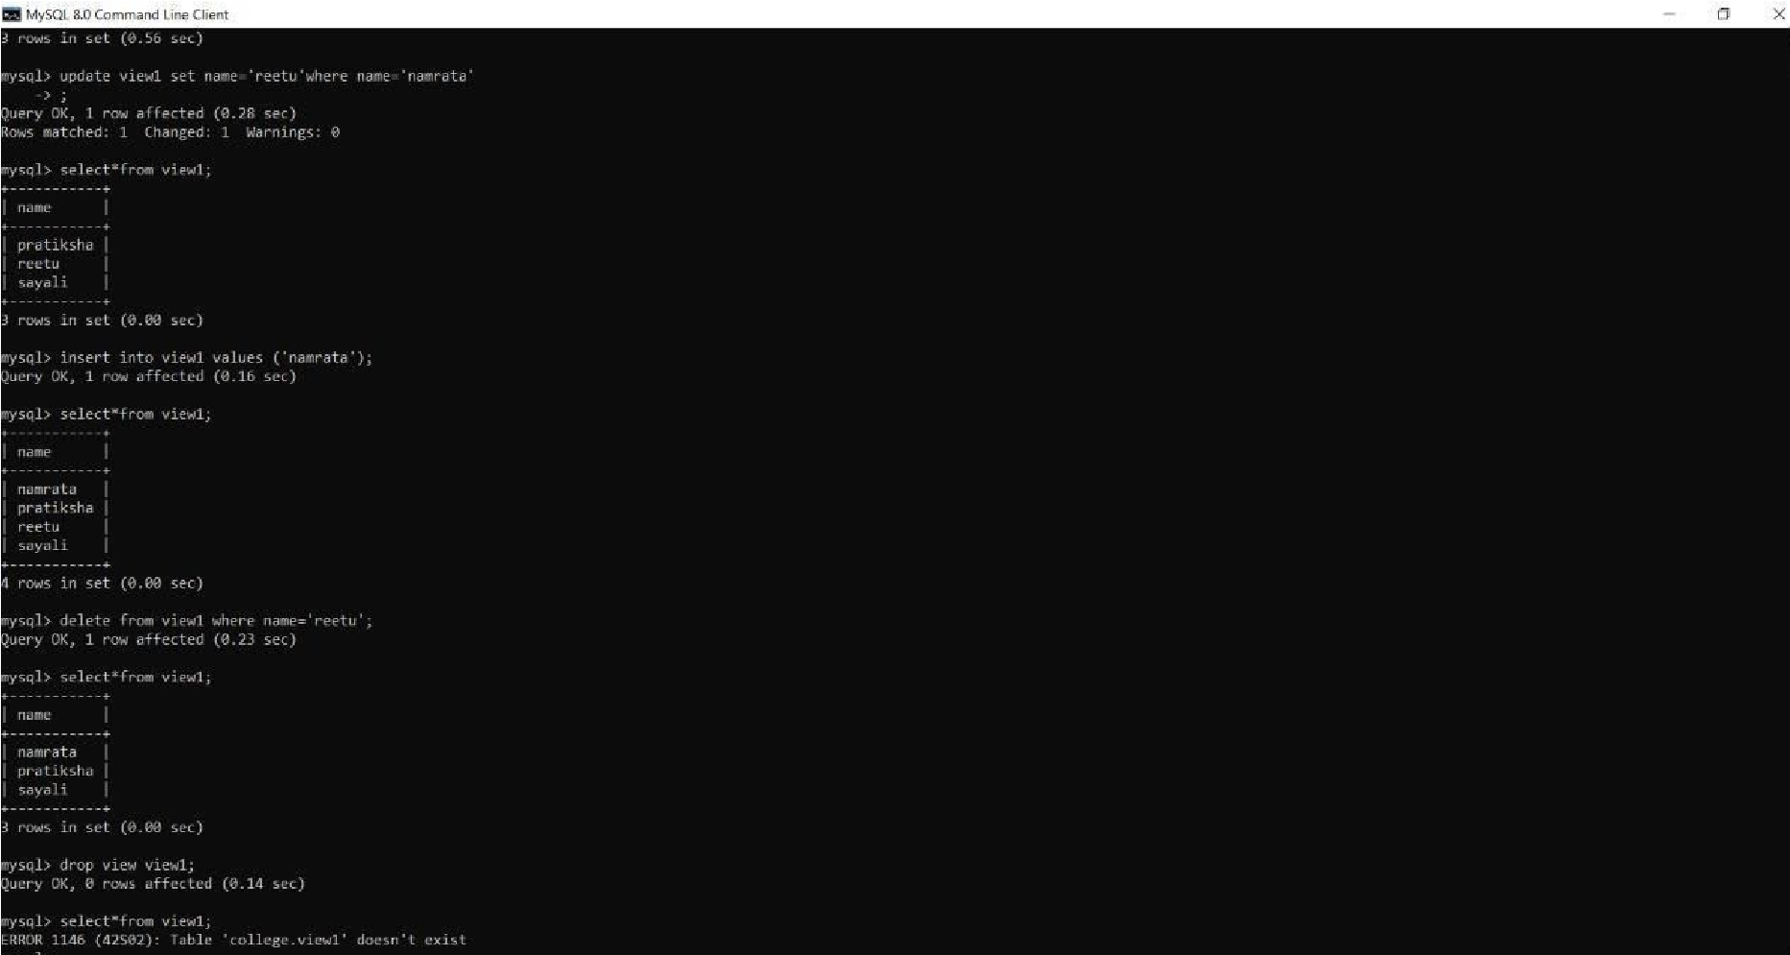

**OUTPUT:**

